Rethinking Women in Hasidic Literature: Between Close and Distant Reading
Chen Mandel-Edrei, Sinai Rusinek, and Gadi Sagiv

Introduction: Scholarly Debates on the Place of Women in Hasidism
Since the early stages of scholarship of Hasidism, questions about the place of women in the movement have sparked inquiries among scholars. Discussions on this topic date back to the 1920s, when Shmuel Abba Horodezky, a pioneering scholar of Hasidism, proposed that women enjoyed “complete equality in religious life” within the movement. In the 1980s, Ada Rapoport-Albert challenged Horodezky’s assertions, arguing that his perspective was colored by a romanticized view of Hasidism and its theology. She pointed out the significant gap between Hasidic ideals and the reality of women’s status within the movement, highlighting its patriarchal nature and the marginalization of women, albeit with some exceptions. Since then, particularly since the early twenty-first century, the debate has continued, with scholars presenting new arguments from various angles. For instance, Tsippy Kauffman suggested that women in peripheral areas of the movement may have had more freedom, albeit outside of the formal social and ritual structures. She argued that despite their exclusion from certain practices, women encountered new spiritual dimensions within Hasidism. On the other hand, Marcin Wodziński expands on Rapoport-Albert’s argument, contending that Hasidism primarily caters to a male audience, with little representation or acknowledgment of a distinct female identity within the movement. Between these opposing opinions, numerous scholars have explored the issue of women in Hasidism through diverse lenses, such as historical periods, theological conceptions, comparisons across different streams of the movement, and more. This ongoing debate has led to a more nuanced discourse, inviting further contributions, which continue in the third decade of the twenty-first century.
This article aims to introduce a novel approach to examining the place of women in Hasidism: applying quantitative methods to employ a ‘distant reading’ of a corpus of Hasidic hagiographic books, followed by analysis of the findings vis-a-vis a more traditional ‘close reading’ of a selection of the stories in that corpus. The quantitative measures to be introduced in this article include annotation of thematic tags of the stories, with a special attention to adding special tags when women are referenced. Such annotation takes into consideration every reference to women in the corpus, rather than base the examination on specific stories selected by the researchers, a selection that is often impressionistic or arbitrary.
The decision to employ this quantitative approach seems a good fit to a basic premise we have regarding Hasidic stories: While the traditional view tends to cast the tsadik (the righteous Hasidic leader) as the central hero of Hasidic hagiographies, we see these hagiographic stories as also depicting a variety of other characters, including the Hasidim (the followers of the leader), and including women. And just as male characters assume diverse roles – ranging from devout leaders, through various profiles of followers, to transgressors – all within the Hasidic milieu, women too occupy their own spectrum within the Hasidic world. This spectrum forms the focal point of our inquiry. Rather than focusing on “righteous” women (tsadikot) or “prominent” women (relatives of Hasidic rabbis whose importance derives from their proximity to the righteous), our aim is to explore the range of actions, practices, and contextual environments in which women expressed their affiliation with Hasidism.
Quantitative analysis is far from being novel in historical research, but it has rarely been implemented in the study of Hasidism. But the novelty of our approach is in its reliance on methods and tools that are considered part of “Digital Humanities” (henceforth: DH). Combining this quantitative approach to Hasidic stories, with methods of Digital Humanities in our toolbox – in particular the aforementioned thematic tagging – allows us to ask new questions, and accordingly suggest new answers. In the following discussion we will focus on two major questions: one of them is a ‘traditional’ quantitative question; the other is a new question. The first question is This question seeks to discover the thematic literary contexts in which women are usually mentioned. Such a question will advance scholarship of Hasidism beyond the old questions of whether the Hasidic movement afforded women with significant roles as members of the movement.
The place of women in Hasidism, with all its importance for the study of Hasidism, is but one possible subject in which the approach of thematic annotation can generate new insights. This study is actually part of a broader project of historical digital analysis of Hasidic stories, in which a corpus of books of Hasidic hagiography has been annotated for the occurrences of various themes. That sort of annotation facilitates a broader set of questions and insights. It is possible, for example, to quantify and examine the semantic contexts of other themes, such as to quantify the occurrences of emotions in Hasidism and re-examine the role of joy, which is commonly associated with Hasidism. Another possible direction is a diachronic examination of occurrences of themes, in order to explore changes in Hasidic mindsets over time. Even more broadly, independent of our corpus of Hasidic books of Hagiography, we offer a general approach of assessing the role of women, as well as other themes, in other literary corpora.

Sources, Questions, and Methodology
Central to the spread of Hasidism among 19th-century Jews were the hagiographical stories lauding the virtuous acts of saints. These tales, imbued with sanctity by Hasidic theology, were sometimes recounted orally by the tsadik (Hasidic leader) but mostly told and disseminated by his (male) followers, fostering a sense of communal identity. The first compilation of Hasidic stories, Shivhei HaBesht (In Praise of the Baal Shem Tov) was published in 1814, first in Hebrew and soon after in Yiddish, by Dov Beer of Linitz and Yisrael Yafee. Despite its immense popularity, no new Hasidic hagiographies emerged in the subsequent fifty years. It was only in the mid-nineteenth century that technological and political factors contributed to the establishment of Hasidic hagiography as a distinct modern genre. This “second wave” of publication of Hasidic hagiography, primarily centered in Lemberg during the 1860s, was an inevitable facet of the local modern cultural development. This flourishing cultural activity mirrored the modernization of the political consciousness among the Jewish masses in Galicia and indicated a quest for answers regarding individual and communal identity. The Hasidic community kept pace with these changes and figures like Menachem Mendel Bodek (1825–1874), Michael Levi Rodkinson (1845–1904), and Aharon Walden (1838–1912), began producing hagiographical booklets intended for both “men of great wisdom” and the common folk to peruse during their leisure time away from Torah study.
Hasidic stories seem to be suitable sources for exploring the place of women in Hasidism. First and foremost, because Hasidic stories are considered in scholarship as the genre best reflecting the daily lives of the Hasidim, with all their diversity. With regard to women, Tsippy Kauffman noted that “by means of stories, one can encounter marginal figures in the culture—such as women, who are much more present in stories than in derashot [homilies], hanhagot [guidelines for conduct], or halakhah [Jewish law]—as objects and as subjects”. Additionally, as David Biale noted, Hasidic stories serve as a platform for expressing tensions within the movement regarding the role of women. Thus, the examination of Hasidic female representation in this context acknowledges these tensions and presents a thoughtful discussion of this subject, without seeking to either glorify or condemn Hasidism as a whole.
In this article we aim to employ our combined approach of distant and close reading on Hasidic stories published in hagiographical collections between 1814 and 1866. Namely, on stories published in the first two “waves” of publishing. The corpus data on which we base our discussion contains the following books of Hasidic stories:
- Shivhei ha-Besht (Kopys, 1814; 88 pages), produced by Dov Beer of Linitz and Yisrael Yafee
- Mif’alot ha-Tsadikim (Lwow, 1856; 36 pages), produced by Menachem Mendel Bodek
- Sipurei Tsadikim me-ha-Hut ha-Meshulash (Lemberg, 1864; 86 pages), produced by Michael Levi Rodkinson
- Shivhei ha-Rav (Lemberg, 1864; 96 pages), produced by Michael Levi Rodkinson
- Adat Tsadikim (Lemberg, 1864; 128 pages), produced by Michael Levi Rodkinson
- Ma’ase Tsadikim (Lemberg, 1864; 72 pages), produced by Menachem Mendel Bodek
- Pe’er mi-Kdoshim (Lemberg, 1865; 64 pages), produced by Menachem Mendel Bodek
- Kehal Kdoshim (Lemberg, 1865; 30 pages), produced by Menachem Mendel Bodek
- Kehal Hasidism (Warsaw, 1866; 118 pages), produced by Aharon Walden

These 9 books, consisting of about 700 pages and 650 stories, provide an exhaustive list of books of Hasidic hagiography during the first fifty years of their appearance (1814–1866). Notably, we excluded from our corpus the book Sipurei Ma’asiot by Rabbi Nahman of Bratslav (printed in 1815), as it is a book of fictional tales rather than hagiography.
This article discusses two sets of questions: (1) The number of references to women in every book of the corpus enables us to discern possible changes over time in the representation of women. Namely, differences between the beginning and in the middle of the nineteenth century; (2) The tagging of various themes in every book of the corpus enables us to discover the thematic contexts in which women are presented in Hasidic stories. That is, what are the most frequent themes that appear in stories in which women are referenced. As a complementary stage, the article first examines each reference through close reading and literary analysis before proceeding to discuss the results and draw conclusions from the complete range of statistical data combined with literary interpretations.
The data introduced here stems from a multi-stage process of scanning, OCR processing, and XML annotation. Through interdisciplinary collaboration between historians and literary scholars, we developed a tagging schema consisting of about 15 top-level categories (e.g., “practice”, “ethics and emotions”) and about 120 sub-tags, such as “agunot” or “prayer”. We applied these tags at the narrative level, marking the presence of a theme within a story rather than the frequency of its textual occurrences. This metadata framework enables scholars to easily retrieve specific story elements through our online platform (https://www.hasidic-stories.org/). For the quantitative analysis of these findings, we leveraged free tools such as Google Colab and OpenRefine to filter data and generate thematic insights.[GS 15/01]
Our approach uncovered several methodological issues, underscoring the limitations of digital and quantitative tools in historical and literary research. However, this only prompted us to be more cautious in our use of these tools and refine our system. Below, we outline each of these methodological issues and briefly explain how we addressed them to improve the accuracy and objectivity of our research.
The first issue we encountered concerns how to identify and count the literary units within the stories. While this may seem straightforward, it becomes problematic due to the difficulty in determining the total number of stories. Hagiographical texts from the 1860s onwards often feature clear separations between individual stories, making it easier to tally them. However, Shivhei haBesht lacks such distinctions. The book follows the traditional hagiographical format, offering a continuous biographical account of the saint’s life, which makes it difficult to identify where one story ends and another begins. Because this issue was recognized by earlier scholars such as Avraham Rubinstein and Gershom Scholem, who noted it while studying the various editions of Shivhei haBesht during their efforts to edit and annotate the text, we decided to rely on their conclusions. Specifically, to incorporate Shivhei haBesht into our analysis, we used Scholem's personal copy of Shivhei haBesht, in which he enumerated the stories in the margins.
The second issue involved annotating references to women. To understand the range of roles attributed to women, our first task was to identify all female characters and analyze the societal, religious, and emotional contexts in which they appear. Given the scale of our project, using distant reading techniques and data retrieval from a large corpus, we sought a more effective tagging system. Relying solely on automated data retrieval based on terms like "woman" or "mother" would be misleading, as these often serve as peripheral details with no real agency. Distant reading methods based on such superficial retrieval would overlook the lack of substantial portrayals of women and their agency. We therefore aimed to develop a method to distinguish passive and incidental mentions of women, primarily as background, from female characters with active roles in the narrative. However, after our assistant completed this task, we found their tagging of 'major' and 'minor' characters to be subjective and inconsistent. As a result, we decided to use simple, objective tagging for any reference to women, without differentiating between dominant or passive roles. This means that drawing meaningful conclusions requires more than digital reading; a deeper close reading is necessary. As shown below, this close reading will nevertheless be guided by statistical data, systematic information collection, and cross-referencing, offering new and valuable insights.
Dealing with the challenge of subjectivity when tagging women, we discovered that this issue extends beyond just that case. The third methodological challenge we faced concerned the subjectivity of the thematic annotation of the stories, influencing the project's system as a whole. While annotation of person and place names is based on a simple straightforward decision whether a given word refers to a name of a person or a place, deciding that a story is part of or related to a theme, is open to interpretations and non-trivial decisions. A scholar of religion would incline to add tags related to religious thought and practice (tags such as “prayer” or “mystical union”), whereas a folklorist would look for topoi. One way to address this challenge was to make sure that our team consists of scholars from more than a single academic discipline: One of us is a literary scholar, whereas another is a historian with a background of “Jewish Thought.”
Despite the limitations we encountered, our awareness of these challenges allowed us to refine and improve our system. By addressing the issues and acknowledging the limitations of the digital methodology, we conducted our research with diligence, resulting in a thorough, thoughtful, careful, and innovative contribution to the study of women in Hasidic stories and Hasidic culture.

Distant Reading: Quantitative Analysis of References to Women and their Contexts
To quantify the representation of women in the stories, we employed a mathematical approach based on their proportional frequency, specifically the ratio of their appearances to the total number of stories within each book (as well as overall). The preliminary results outlined here offer insights into the role of women in Hasidic literature and, more broadly, in Hasidic culture. They serve as a starting point for a more in-depth analysis through close reading, which will be presented in the following section.
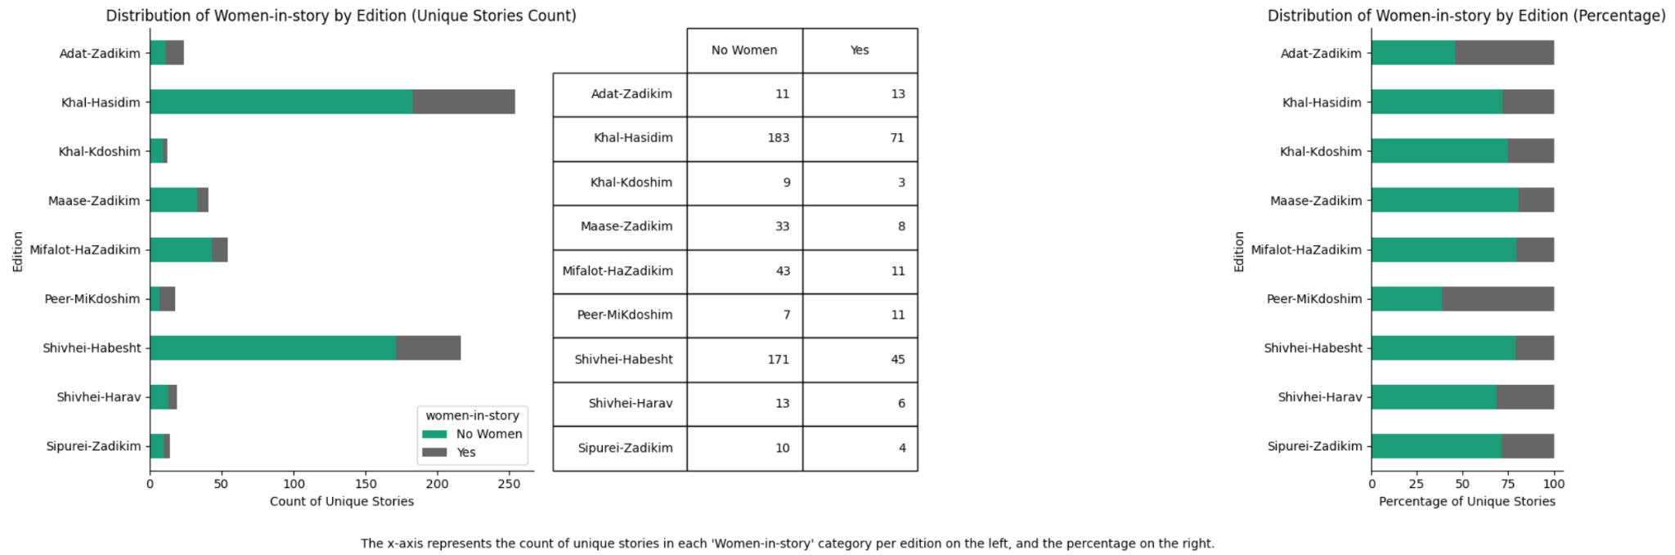
Go to the relevant notebook in colab, sort according to years (Shivhei ha-Besht first), and copy the diagram to here.
When examining the proportion of female characters in each book within our corpus, we find that the number of references to women is similar in Shivhei ha-Besht and the hagiographic collections of the 1860s. This challenges previous studies that emphasized the prominence of women in Shivhei ha-Besht compared to later works. Notably, Gedalia Nigal supported this argument with numerical data, but our comprehensive count contradicts his findings. Rivka Dvir-Goldberg echoed Nigal’s claim, yet her approach—first identifying prominent women and then counting them—introduces a selection bias By contrast, our systematic and objective method avoids the impressionistic tendencies that shaped their conclusions.
Ada Rapoport-Albert observes that exceptional women in Shivhei ha-Besht belong exclusively to the elite—either as relatives of tsadikim or as wealthy supporters—rather than representing common women. Their portrayal reflects the Hasidic tendency to construct idealized figures, much like the tsadik himself. Though these representations offer a glimpse into imaginative possibilities for women in Hasidic literature, they remain largely disconnected from the experiences of ordinary women. Nonetheless, the very presence of these extraordinary figures opens a space for reimagining women’s roles within the deeply traditional Hasidic framework.
Beyond the proportion of female characters in our corpus, our digital method enables a broader examination of the semantic contexts in which women are mentioned. One of the most significant findings from this distant reading approach concerns the role of women in Hasidic practice. In what follows, we outline the process that led to this discovery. We begin by presenting our digital distant reading of the semantic field categorized under the top-level tag “Practice.” We then refine our analysis by examining sub-tags to determine which are most frequently associated with female characters. Notably, when analyzing the relative frequency of female characters in stories tagged under “Practice,” we find that women appear in every narrative involving pidyon (redemption payments) [Figure 1]. Traditionally, pidyon refers to the practice of giving a monetary gift or donation to the saint as a 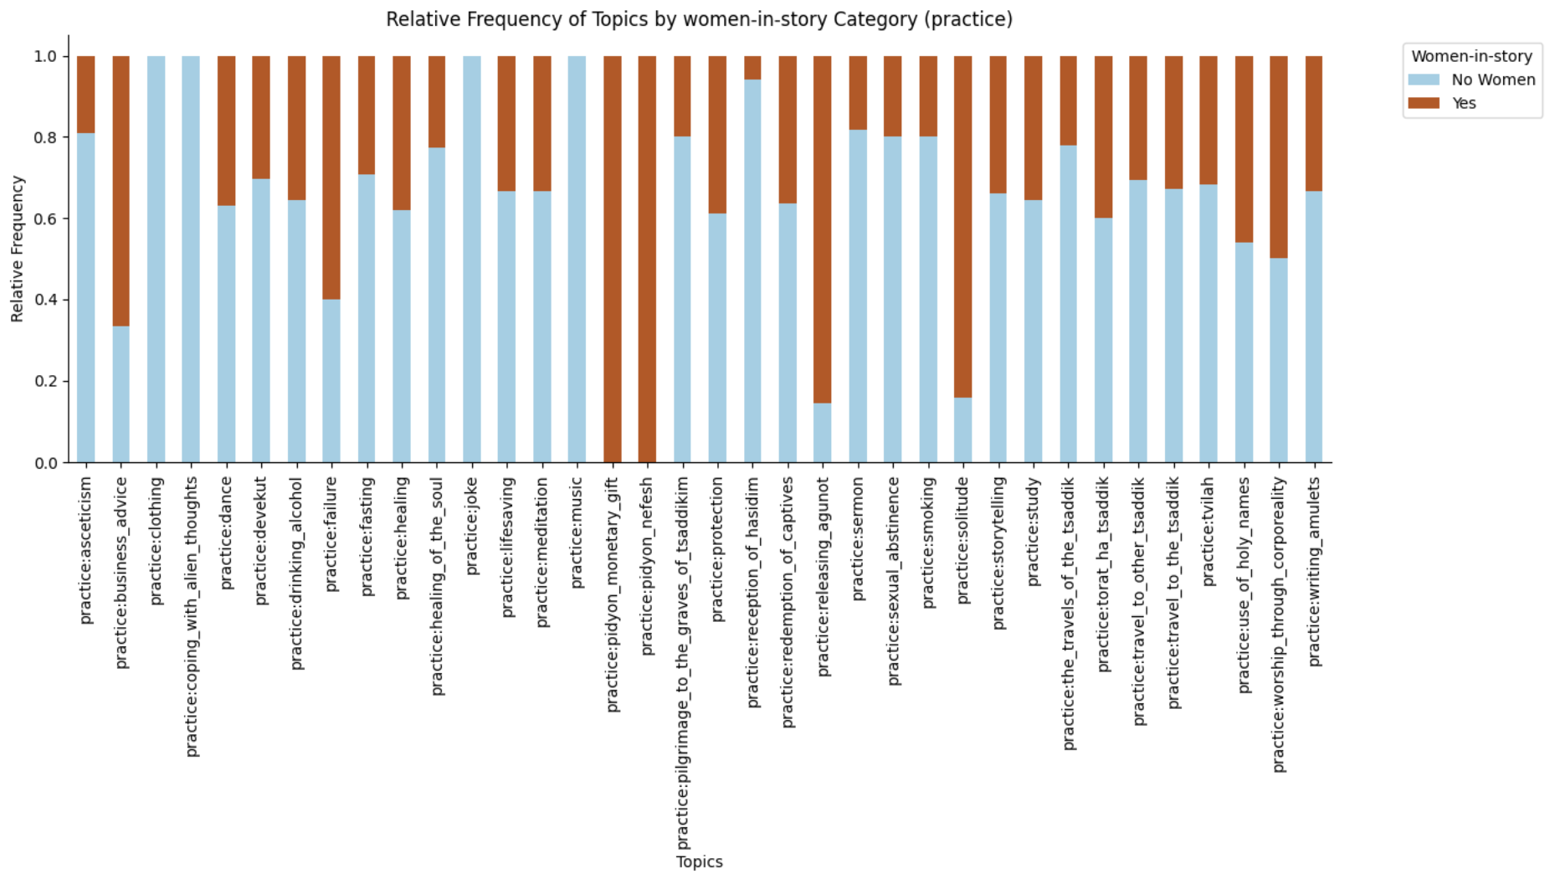form of spiritual exchange. Money is often seen as a means of securing spiritual blessings, intercession, or protection. In Hasidism, this practice is rooted in the belief that the tsadik has a special connection with the divine and can mediate between the material and spiritual worlds on behalf of the donor. The exchange has developed into a wider economic mechanism that helps maintain hasidism as a larger movement, however still keeping the intimacy of havurot, smaller units of havurot. In this context it is surprising that female characters consistently appear in narratives about pidyon, usually performed by male hasidim. While this stands out in comparison to other practices, as with any distant reading, this observation might be insignificant. Indeed, out of the six hundred and fifty stories, only seven address the practice of pidyon. But, while this may seem like a small number, it is nevertheless notable that pidyon is never depicted without female characters.
Additionally, when examining another category—Ethics and Emotions—we find that the three topics with the highest relative frequency of women in stories are poverty_virtue, resisting_temptation, and lust [Figure 2]. 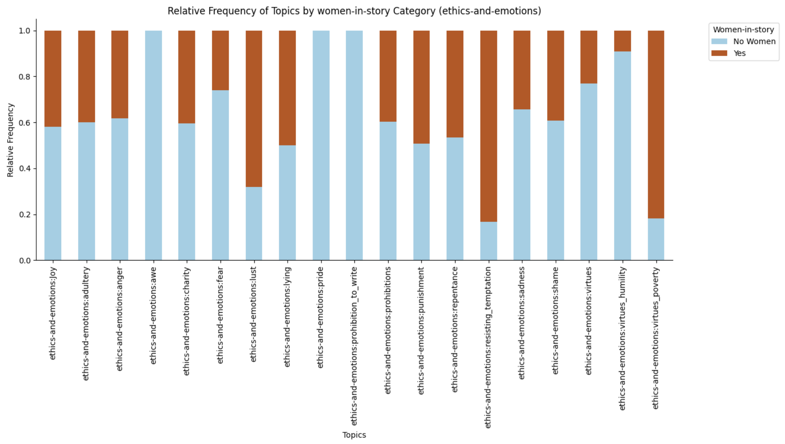The latter two are expected, as women often appear as objects of sexual desire to be resisted, as previously discussed. However, the connection between women and poverty is less typical. Out of the twenty-two stories addressing poverty as virtue, sixteen present female characters. Combined with the former results, this strengthens the hypothesis that Hasidic stories may associate women with financial matters.
Second only to pidyon, solitude and releasing_agunot emerge as additional significant themes involving female characters [Figure 1]. It is unsurprising that stories about agunot feature a high frequency of female characters, as this practice inherently involves women and doesn’t reveal anything new about Hasidism. What is striking to find is a notable presence of women in stories about solitude—a practice typically associated with tsadikim, who pursue spiritual elevation and bodily purity by withdrawing from worldly matters. Upon closer examination, these stories reveal that women often play a supportive role, facilitating their husbands’ detachment from material concerns. In many cases, they serve as breadwinners, managing the household and sustaining their families during their husbands’ absence. Prominent examples include Hanna, the Besht’s wife, and the unnamed wife of Avraham haMalakh.
As our suspicion of a literary connection between women and economic matters deepens, many questions remain unresolved. What roles do women play in these stories? Are they participants in pidyon, or do they oppose it? Do they embrace the notion of poverty as a virtue, or resist it? Is there a historical context that ties women to monetary practices? Do these stories offer insights into the role women may have played in Hasidic economic structures? To determine the significance of these statistical and quantitative findings and uncover any historical or literary meaning, we must return to a closer examination of the texts themselves, however now directed by novel findings of distant reading. It is at this point that the distant reading directs us systematically toward relevant examples, rather than a human serendipitous discovery.

Close Reading: Women in Pidyon Stories
Before delving into the close analysis of stories involving women and pidyon, it is essential to consider the broader historical and economic context of women's roles in early modern Polish Jewish society. The activity of early modern Polish Jewish women in their household’s economies is hardly surprising. Several scholars have already discussed the notable involvement of women in their household’s economies. Although they were considered inferior or subordinate to their husbands, they were still considered partners with their husbands in financial matters, as were Christian women in their households. This historical perspective not only illuminates women’s roles within the household as economic agents but also reveals a more complex literary representation of their symbolic and financial participation in what is largely a “masculine sect.” Historically, the role of supporting one’s husband was already well-established in traditional societies. Glenn Dynner explains that alongside physical beauty and yihus (familial prestige), potential brides were “valued mainly for their promised dowries, economic skills, and assets,” which could enable them to support a husband dedicated to Torah study.
The representation of women and pidyon in early polemical texts offers additional insight into the perceived role of women in Hasidic economic and spiritual practices. Early anti-Hasidic polemical texts, known as mitnagedic writings, include mentions of women in the context of pidyon. Some portray frivolous women seeking the tsadik’s blessing for earthly matters, such as bearing sons, while one account describes a woman who refuses to give pidyon and faces the tsadik’s vengeance. Later maskilic polemics similarly depict women traveling to tsadikim and offering pidyon for fertility—efforts presented as futile. However, rather than focusing solely on women’s participation in economic transactions, our discussion examines the extent to which financial capital afforded women social agency within Hasidism, particularly in spiritual practices like pidyon, where wealth carried religious significance. This aspect of female agency is difficult to discern from polemical sources or homilies alone.

A closer reading of pidyon stories reveals that women occupy diverse roles, ranging from opposing the mystical nature of the practice to actively participating in its performance. Most discussions of women in Hasidic tales focus on their sexual or domestic roles, often reinforcing stereotypical depictions. Women are typically portrayed as mothers or birth givers—traditional feminine roles—or as polarized figures, either saints or sinners. However, their roles in economic contexts are detached from both their femininity and spiritual status, offering a fresh perspective on their historical position and complicating their participation in what is largely a "masculine sect." The following analysis explores pidyon stories from Shivhei HaBesht (50B), Mifalot haTsadikim (8), and Kehal Hasidim (115; 230), each of which sheds light on a different aspect of women's relationship to Hasidism.
The story from Shivhei Ha-Besht recounts the actions of the wife of a Hasid named Rabbi Yosef, who takes the initiative and directs the entire process of a pidyon, although she never personally meets the tzadik. When she realizes she is having difficulty in childbirth (maksha laledet), she instructs her husband to visit the Magid of Mezeritch and request a pidyon nefesh on her behalf. In their exchange, her husband says: “‘If you give me the key to the [money] chest, allowing me to take as much as I please, I will go, and if you do not, I will not go.’ So she gave him the key and a cloth [to carry the money], and he took 160 gold coins and went to the Magid.” This conversation clearly demonstrates that the woman not only directs her husband to perform the pidyon, but also serves as the household’s treasurer, controlling access to the family’s finances. Her husband requires her permission to withdraw money. Despite this authority, however, her position does not grant her entry into the male-dominated mystical sphere, as it is her husband who carries out the spiritual exchange with the tzadik.
Rabbi Yosef's wife's status allows her to play a key role in the mystical performance, making her a significant figure in its execution. This highlights the crucial role that economic power played in empowering women. Shaul Stampfer demonstrates how, in the Middle Ages and early modern period, women were often central to their family’s finances. “The recognition of wives' economic contributions limited the authority of their husbands.” This economic influence often created a change of power within households, where women could challenge traditional gender hierarchies. Indeed, although this economic power was not directly tied to the spiritual realm of Hasidism, it provided women with an alternative means of engaging with the movement's practices and values. As Haviva Pedaya has specifically argued, it was the Magid of Mezeritch who first redirected pidyon funds toward secular purposes, particularly for supporting the havurah and establishing the hatser (Hasidic court). This suggests that with the formalization of Hasidism, economic contributions became another means of engaging with the sacred community (havurah). In this context, women were able to carve out a limited, but nonetheless meaningful, form of Hasidic agency through their financial involvement.
This form of female economic agency takes on diverse expressions, some of which are less cooperative. In another story from Bodek’s Mif’alot ha-tsadikim, we encounter a woman, again the family’s treasurer, who refuses her ailing husband’s request to withdraw money from the family’s savings for his personal pidyon nefesh (redemption). She argues that after consulting numerous doctors, there is no point in turning to a saint, as his recovery depends solely on God's will. Despite his loss of hope, the husband insists she give him the money. Eventually, she consents, but when the hasid presents the money to the tsadik, it is not for his recovery but to ensure the saint's intercession in the afterlife. The wife’s economic authority allows a realistic perspective to emerge forcefully in the story. Her pragmatic assessment of her husband's condition is validated when he soon passes away, and the narrative shifts to his afterlife, where the rabbi fulfills his promise of assistance. The woman challenges the hasidic reasoning, though not completely. While she is not portrayed as a rebel, she nonetheless embodies an alternative, more grounded and practical outlook. Unlike other stories, where such realism is undermined by hasidic mysticism, here, the husband does not experience a miraculous recovery. Instead, the realistic and modern perspective coexists with the mystical, each representing different layers of reality—one in life, the other in the afterlife.
A similar debate over the proper use of family funds appears in a story from Kehal hasidim, where a woman's business decisions are challenged by Hasidic social circles and theology. In the story, a wife gives her husband money to buy wine and candles for Shabbat. On his way, he encounters Rabbi Moshe Leib, who persuades him to join him for drinks at a pub. As they drink, Rabbi Moshe Leib eventually convinces the man to invest all his money in the town auction for the position of general lessee, ensuring it stays in Jewish hands. When the man returns home, he tells his wife only that he spent the money on drinks, leaving him unable to buy wine. This angers his wife, who is upset by his irresponsible use of their money. Later, after Shabbat, the man attempts to take all their savings to the town auction, but his wife confronts him, and he explains the entire situation. After their discussion, the narrator notes that "he went on in peace." The story concludes with Rabbi Moshe Leib performing a pidyon for the man in return for his commitment to help the Jewish community, sacrificing all his savings: "And the holy tzaddik performed a pidyon for his body, spirit, and soul, and bestowed upon him sustenance, blessing, and great success."
This story does not set up a conflict between the mystical and the realistic but rather between the private and the communal. The wife manages the money prudently, ensuring they have what they need, while the husband spends recklessly on drinking and socializing. However, it is through this socializing that he gains access to business opportunities that are closed to his wife. Although she eventually agrees to his decision to sacrifice their savings for the collective good, the story portrays her as an outsider to these social and communal dynamics. Like the previous story, women here do not oppose Hasidic practices, but they present obstacles to its operation. These stories emphasize that while women's economic awareness grants them significant agency within the family, it does not elevate their standing within the male-dominated Hasidic spheres. They remain on the sidelines, supporting the social and mystical opportunities that arise for their husbands rather than actively participating in them.
Another story from Kehal Hasidim presents a different relationship between women and pidyon (redemption payments). The final story to be discussed here features a woman who not only manages her family’s finances but is also a businessperson in her own right. This woman turns to a group of tsadikim gathered in Ropshitz likely for the yahrzeit (anniversary) of Rabbi Naftali Tzvi’s passing, seeking their assistance. Her business partner had taken all her money with him on a business mission but seemingly died on the way, leaving her financially ruined. In her despair, she begins to cry. The story recounts that "all the tsadikim who were there greatly increased her confidence and strength, assuring her that no harm would come to her and that she would soon find the money, each one according to the strength of his promise." All but one—the Rabbi of Kaminka—offered such reassurances. Instead, he begins to tell a story, claiming that the woman’s predicament could be a result of a debt owed to him in a previous lifetime (gilgul). The story he recalls introduces the concept of a pidyon that was once given to the Besht as a form of spiritual rectification (tikkun) for a past-life debt. According to the Kaminka rabbi, her loss was part of such rectification. However, the story provides no concrete or realistic solution for the woman, who leaves the room only with this mystical explanation.
In addressing her very real and material crisis through the lens of gilgul, the Rabbi of Kaminka draws a parallel between her condition and the story he has heard about the Besht, yet a speculative one. The narrator contrasts two poles: on one side, a woman in search of practical financial relief, and on the other, tsadikim speaking to her in abstract, speculative terms. This stark contrast between financial matters and pidyon diverges from earlier depictions we have seen, especially given the extreme stances of both sides in this story. The woman does not engage in any pidyon practice, nor does she consent to using her money for this purpose. Similarly, the tsadik neither performs a mystical act nor persuades her into a pidyon. Instead, he speculates, repeatedly saying, “Who knows? This event might be the result of a previous gilgul,” or, “Who knows in which gilgul this woman owed this man money?” There is no decisive resolution. The story does not describe a mofet (miraculous act) by any tsadik. It simply contrasts the woman’s financial distress with the speculative, mystical reasoning of the tsadikim. In the end, the woman does not regain her wealth, and no tikkun or pidyon is carried out by tsadikim.
Representations of women in Hasidic literature reveal points of potential power, portraying them as capable of influencing interpersonal dynamics and asserting their positions. However, despite these moments of agency, women were largely excluded from shaping the spiritual ethos and practices of Hasidism, which remained inaccessible to them. Historically, economic power served as one of the few significant avenues for women to assert influence, particularly for widows who often wielded considerable authority as international merchants. Temrel Sonnenberg-Bergson exemplifies this dynamic in the Polish Hasidic world, emerging as a leading patron of Hasidic courts and a veritable “king-maker.” The stories discussed here reveal that, although women were largely excluded from formal participation in the spiritual realm of Hasidism, wealth offered them alternative avenues for partial engagement with the Hasidic experience. Through financial power, women found ways to exert influence within the institutional frameworks of Hasidism, which otherwise constrained their social opportunities.
Additionally, the literary treatment of Hasidic matters involving economic power reflects a paradigm shift. While most narratives often depict women relying on the male-oriented movement, such as through their dependence on tsadikim, these stories reveal how tsadikim and their followers turned to women to access their resources. The stories portray cases in which Hasidism, as a movement, relies on women to sustain its rituals and institutions. By controlling financial resources, women created scenarios where hasidim sought their approval to maintain Hasidic experience. This dynamic afforded women with a spectrum of roles within the Hasidic framework: they could resist its ethos, facilitate male performances, or even take on active, performative roles themselves.

Revisiting Women in Hasidism
In conclusion, a quantitative approach reveals patterns and associations in Hasidic tales that might otherwise remain unnoticed. The distant reading of these stories highlights a strong and often overlooked connection between women and financial matters.
Traditional research has tended to frame women's roles in Hasidic culture within a limited "feminine" sphere, yet the narratives analyzed here underscore their significant economic influence within the movement. As we have seen in our close reading, women’s status as breadwinners sometimes positioned them in opposition to the Hasidic spiritual and communal ethos surrounding pidyon (redemption payments). However, this same financial agency also enabled female participation in Hasidic rituals.

Distant reading uncovers the interconnections between women and economic activities, particularly pidyon, that might otherwise remain hidden in traditional analyses. By analyzing a larger corpus of stories, this approach reveals clusters of narratives where themes of financial transactions and women's roles overlap. These clusters highlight the significant yet often overlooked economic agency of women in Hasidic life. While works like Nigal's Women in Hasidic Stories examine women’s household roles, they typically omit their involvement in financial practices like pidyon. Distant reading, however, reveals how these stories are frequently centered around women’s participation in sustaining Hasidic communities through economic activities, whether by managing redemption payments or supporting the financial framework of the Hasidic court. This broader perspective uncovers the essential, though peripheral, economic contributions women made to the Hasidic movement, even as they remained marginalized in spiritual narratives.
Hasidic literature, which reached a wide popular audience, provided women readers with access to communal narratives and spiritual events from which they were often excluded in real life. More specifically, the pidyon stories grants women considerable literary attention, underscoring the indispensable role of women in the Hasidic economic sphere. As Hasidism institutionalized, financial considerations became integral to its structure, relying on women’s collaboration in economic activities such as pidyon, leasing arrangements under Hasidic leadership, and the broader sustenance of the Hasidic court. While their participation was often peripheral, their agency within the economic framework was undeniable.
Despite this crucial involvement, women were largely excluded from actively shaping Hasidic spiritual practices, which remained a male domain. The few representations of female power and influence in Hasidic tales hint at the possibility of an alternative religious role for women—one that never fully materialized. Historical figures like Tamarl, who leveraged financial resources to gain prominence as a patron of Hasidic courts, exemplify this rare but significant phenomenon. However, the majority of female characters encountered in these stories do not undergo Hasidization (the process of becoming devoted followers of a tsadik), nor do they experience devekut (spiritual attachment) or self-revelation. Unlike their male counterparts, women are notably absent from narratives that explore the master-disciple relationship [See figure 1] —a foundational element of Hasidic personal and spiritual development. For most ordinary women in these tales, their connection to the tsadik holds little significance for their individual growth, reinforcing the broader exclusion of women from the transformative spiritual experiences central to Hasidic life. Yet, while women’s participation in Hasidic culture often occurred on the margins, it was not devoid of agency.

Appendix: Technical Description of the Project
In a project [anonymized] we did the following steps:
- Prepare a list of books of Hasidic hagiography
- Acquire quality scans of those book
- OCR and layout analysis by Transkribus
- Conversion of the text to the TEI standard
- Annotation of persons, places, and themes (including references to women) of the TEI files using TEI Publisher
- Provide a browsing interface for end-users, facilitating various combinations of queries of persons, places, and themes, in various sets of stories.

ADDITIONAL MATERIALS FOR CONSIDERATION WHEN EDITING FINAL DRAFT

The following article by Rosman could also be of great significance to our discussion here. He distinguishes between women as bystanders, facilitators, and performers. I think his discussion can help us make the historical and cultural discussion more accurate. Also he refers to different scholarly approaches and provides his own approach to the question of female agency in the middle-ages and early modern period. Rosman, “The History of Jewish Women in Early Modern Poland: An Assessment,” POLIN 18 (2005)”

Some examples are: Naftali Loewenthal, “‘Daughter/Wife of Hasid’ or ‘Hasidic Woman,’” Mada‘ey HaYahadut 40 (2000):21*–28*; Naftali Loewenthal, “Women and the Dialectic of Spirituality in Hasidism,” in Bema’agaley Hasidim, edited by Immanuel Etkes et al. (Jerusalem: Bialik Institute, 1999), 7*–65*; Nehemia Polen, “Miriam’s Dance: Radical Egalitarianism in Hasidic Thought,” Modern Judaism 12 (1992): 1–21; Moshe Idel, “Some Observations on Gender Theory in Hasidism,” Ruah Hadashah BeArmon HaTorah, edited by Ronit Ir-Shay and Dov Swartz (Ramat Gan: Bar Ilan University Press, 2018), 83*–103*; Leore Sachs-Shmueli, “Shekhinah and the Revival of Feminine God Language,” Modern Judaism 39, no. 3 (2019): 347–369.
Shmuel Abba Horodezky, Hasidism and the Hasidim, vol. 4 (Berlin: Dvir, 1923), 68 [Hebrew].
Ada Rapoport-Albert, “On Women in Hasidism: S. A. Horodecky and the Maid of Ludmir Tradition,” in Jewish History: Essays in Honour of Chimen Abramsky, ed. Ada Rapoport-Albert and Steven J. Zipperstein (London: P. Halban, 1988), 495–525. Rappaport-Albert excludes mothers or wives of tsadikim who were accorded new social value due to their relation to the saint. Similarly, according to her, in the twentieth century HaBaD Hasidism reshaped the role of women as active members of the movement. See Ada Rapoport-Albert, “From Woman as Hasid to Woman as ‘Tsadik’ in the Teachings of the Last Two Lubavitcher Rebbes,” Jewish History 27, No. 2 (2013): 435–73; Rapoport-Albert, “The Emergence of a Female Constituency in Twentieth-Century HaBaD,” Hasidic Studies: Essays in History and Gender (Liverpool: Littman Library of Jewish Civilization, 2018), 368–426.
Tsippy Kauffman, “Hasidic Women Beyond Egalitarianist Discourse,” in Be-Ron Yaad: Studies in Jewish Thought and Theology in Honor of Nehemia Polen, edited by Ariel Evan Mayse, Avraham Yizhak Green (Boston, MA: Academic Studies Press 2019), 223–257.
Marcin Wodzinski, Hasidism: Key Questions (New York: Oxford University Press, 2018), 43–85.
In Biale’s words literary analysis of this controversial issue should “either apologetically describe this folk movement’s virtues or denounce its values.” See David Biale, “A Feminist Reading in Hasidic Texts,” in Harimi BaKoah Kolekh: Female Voices and Feminist Readings in Jewish Studies, edited by Renée Levine-Melammed (Tel Aviv: Yedi’ot Aharonot, 2001), 144. [Hebrew]
Chen Mandel-Edrei, ???
We use the term ‘producer’ as an umbrella-term covering all terms related to the books’ production mentioned at the paratexts of those books: collector, editor, brought to print, etc.
For a summary of these scholarly views, see Uriel Gellman, “Stories,” in: Studying Hasidism: Sources, Methods, Perspectives (New Brunswick NJ: Rutgers University Press, 2019), 60–74.
Adat Tsadikim was printed twice the same year. We used one of the prints. For the purposes of the current article, as long as the content is more or less the same, the specific edition is of no importance.
This article was funded by grant no. 1478/21 awarded by the Israel Science Foundation (ISF) for a project entitled “Historical Digital Analysis of Hasidic Stories until 1914”, conducted in collaboration with Uriel Gellman and Marcin Wodziński. The authors would like to thank research assistants Dorit Peretz and Yeshayahu Goldenhersch for their valuable effort, and to Zeev Kitsis for his advice.
The term "pidyon" is derived from the Hebrew word for "redemption." Our discussion relates to pidyon both as monetary gift and the more specific pidyon nefesh, often interrelated.
"[T]he innovation lies in directing part of the pidyon (redemption fund) to a very specific type of charity: hospitality and mutual support among the members of the group (havura), which specifically means providing for their livelihood during the pilgrims' stay with the holy man. This constituted a new, permanent and defined economic system, tied to the new way of life of the hasidim who gathered around their leader as a group for religious work." (Pedaya, “The Social-Religious-Economic Pattern in Hasidism,” 344. [Hebrew, translation is ours]
Ben Amoz and Mintz’s translation in In Praise of the Besht, adopts a third-person perspective in place of the original first person and softens the tone, thereby reducing the sense of conflict in the interaction between the husband and wife. Consequently, I have opted to use my own translation, which reflects the nuances of the original Hebrew text. See Ben- Amos and Mintz, In Praise of the Besht, 109.
Shaul Stampfer. Families, Rabbis and Education: Traditional Jewish Society in Nineteenth-Century Eastern Europe. The Littman Library of Jewish Civilization, 2010), 129.
Pedaya,”the Social-Religious-Economic Pattern in Hasidism”
On the pidyon practice in Hasidism see: Haviva Pedaya, “On the Development of the Social-Religious-Economic Pattern in Hasidism: The Pidyon, Ḥavurah, and Pilgrimage” in Tsaddik ve-Eda: Hebetim Histori’im ve-Hevrati’im be-Heker ha-Hasidut, ed. David Assaf (Jerusalem: Shazar, 2001): 331; David Biale et al., Hasidism: A New History, (Princeton N.J.: Princeton University Press, 2018), 424—428
Bodek, Mifl’aot ha-tsadikim, EDITION AND PAGE NUMBER____
REFERENCE ARTICLES ABOUT HASIDIC TALES DEFYING MODERNITY (THERE ARE A FEW)
Waldan, Kehal Hasidim, _______
The tsadik’s interaction with the lessee and their informal conversation at the bar highlights the moral avenues through which tsadikim sometimes operated. As a non-formal movement without an official role in the kahal, Hasidism provided an alternative means of supporting Jewish communities. Though they lacked the formal authority of the kahal, Hasidic leaders were also unburdened by the legal responsibilities and the complex task of maintaining equilibrium between Jews, their Christian neighbors, and the governing authorities—a balance that the kahal was tasked with preserving. This conversation illustrates the observation that “the Hasidic leaders of the first and second generations… did not engage in this area [of leasing] according to communal regulations [takanot ha-kahal] related to property rights. Rather, they shifted their activities in this field from the legal and organizational spheres to the moral realm, a key foundation of Hasidic thought.” (Chone Shmeruk, “The Hasidic Movement and the ‘Arendars’” Zion 35, (1970): 185.
Kehal hasidim, ___________________
Kehal hasidim, ______________
For recent scholarship see, for example: Sam SB Shonkoff, “Gender in Martin Buber’s Hasidic Tales,” The Leo Baeck Institute Year Book 68, no. 1 (2023): 91–107; Zeev Kitsis, Ha-morim ha-gedolim shel ha-ḥasidut: min ha-baal shem tov ve-ad rabbi tsadok ha-cohen mi-lublin (Rishon LeZion: Miskal, 2023), pp. 386–406.
Tsippi Kauffman, “The Hasidic Story: A Call for Narrative Religiosity,” The Journal of Jewish Thought and Philosophy 22 (2014), 125.
Dvir-Goldberg, “The Sound of a Subterranean Spring: Characterization of a Woman in a Hassidic Tale,” Jerusalem Studies in Jewish Folklore 21 no. 1 (2001), 41
Dynner, “Those Who Stayed: Women and Jewish Traditionalism in East Central Europe,” in New Directions in the History of the Jews in the Polish Lands, ed. Antony Polonsky, Hanna Węgrzynek, and Andrzej Żbikowski, (Boston, MA: Academic Studies Press, 2018): 295–312; Moshe Rosman, “The History of Jewish Women in Early Modern Poland: An Assessment,” POLIN 18 (2005): 25–56; Rosman “To Be a Jewish Woman in Poland-Lithuania in the Early Modern Period,” Continuity and Crisis: The Jews of Poland and Their Legacy, Volume 2 edited by in Israel Bartal and Israel Gutman (Jerusalem: Shazar, 2001): 415–434 [Hebrew].
Dynner, “Those Who Stayed,” 300
Dynner, “those who stayed” 308; Kauffman “Temerl, the Female Hasid.”
We are aware of the fact that Hasidic stories appeared not only in hagiographical collections, but also in books of homilies. Conversely, collections of hagiography sometimes contain literary units which are difficult to classify as “stories”. Namely, literary units of halakhah or homilies. Yet, the fact that these literary units were included in a collection perceived as Hasidic resulted in their inclusion in our investigation.
Mordecai Wilensky, Hasidim u-Mitnagedim, Vol. 2 (Mosad Bialik, 1990), 66, 247.
Ibid., 317.
See, for example, Joseph Perl, Megale Temirin, ed. Jonatan Meir, Vol. 1 (Jerusalem, 2013), 55.
Nigal, ____ (pp. 95-97)
Dvir-Goldberg writes, “Certainly, we observe that two notable aspects set apart the portrayal of the Besht and the content of Shivhei HaBesht from all other Hasidic literature regarding women: a connection characterized by mutual understanding and partnership between couples, and an overall positive and encouraging stance vis-à-vis women. It is conceivable that the distinctive perspective of the Besht to some degree influenced his followers and those who have written about him, causing them to incorporate a substantial number of stories about women within Shivhei HaBesht and to portray women in this work using more supportive and affirmative language” (Rivka Dvir-Goldberg, “The Besht and ‘His Pure Notebook’: The Treatment of Women in Hasidic Literature,” Masekhet 3 (2005): 61 [Hebrew]).

